
UNIVERSITY OF GUYANA

[Formal Proposal title]

A Formal Proposal
Submitted to the Department of Computer Science
Faculty of Natural Sciences
UNIVERSITY OF GUYANA

in partial fulfillment of
the requirements for the
degree of

Bachelor of Computer Science

Department of Computer Science

by

John P. Freely

December 2017

UNIVERSITY OF GUYANA
FACULTY OF NATURAL SCIENCES
DEPARTMENT OF COMPUTER SCIENCE

FORMAL PROPOSAL PANEL

________________________________
John Smith, Ph.D.

________________________________
Supervisors
Jane Doe, Ph.D
School of Education.

________________________________
Ray Mann, PhD.

___________________________________
William A. Williams, PhD.
Primary Advisor
Researcher

Student: John P. Freely
Table of Contents

PROPOSAL PANEL ii
List of Tables viii
List of Figures ix
List of symbols xi
Chapter 1. Introduction 1
[includes areas such as background to the problem, statement of the problem, research objectives, research questions, motivation]
1.1 Sub Chapter 1.1 1
1.2 Sub Chapter 1.2 3
1.3 Sub Chapter 1.3 5
1.5 Thesis Outline 6
Chapter 2. Literature Review 7
2.1 Sub Chapter 7
2.2 Sub Chapter 9
2.3 Sub Chapter 10
2.4 Sub Chapter 12
2.4.1 Sub Sub Chapter 13
2.5 Sub Chapter 15
2.6.1 Sub Sub Chapter 18
Chapter 3 to [n]. Other CHAPTERS 20
[here you may include any additional chapters that are relevant to your research. They should be appropriately named such as "Design", "Methodology"]
3.1 Sub Chapter 22
3.1.1 Sub Sub Chapter 22
3.1.2 Sub Sub Chapter 24
3.1.3 Sub Sub Chapter 25
3.1.4 Sub Sub Chapter 26
3.1.5 Sub Sub Chapter 27
3.1.6 Sub Sub Chapter 28
3.1.6.1 Sub Sub Sub Chapter 28
3.1.6.3 The Representation of Prosodic Phrases 30
3.2 Sub Chapter 31
AppendiCIES 73
A1. Treatment Group Background Data 74
A2. Treatment Group Post-Test Questionnaire Results 75
References 91
Use Word’s Table of Contents feature to generate your TOC automatically

list of Tables

Table 5.1 - Flesch Readability Score Descriptions 57
Table 5.2 – Reading Texts Used in the Evaluation 57
Table 5.3 – Mean Reading Rates Gathered from the Experiment 61
Table 5.4 – Mean Comprehension Scores Gathered from the Experiment 62
Tables are named as chapter number followed by table order within the chapter.
E.g. Table 5.4 indicates Chapter 5 and the fourth table in this chapter.

List of Figures
Figures are named as chapter number followed by figure order within the chapter.
E.g. Figure 1.1 indicates Chapter 1 and the first figure in this chapter.

Figure 1.1 – Elements of the Infojector utility 4
Figure 2.1 - The Stages of Reading - (Shepherd and Unsworth-Mitchell, 1999; Strydom & Du Plessis, 2001). 8
Figure 3.1 - Based on the intonation of “You might have told me”, the speaker can imply indignation [1] or doubt [2] (Bollinger 1989; as referenced by Rosenberger, 1998). 23
Figure 3.2 - Rosenberger shows that the common greeting “Hello” can convey mood based on the intonation used. The interpretations are as follows: [1] cheery, [2] sexual attraction; [3] indifference. 23
Figure 3.3 - An example of relative prominence created by lexical stress or accent (Rosenberger, 1998). 24
Figure 3.4 - The comparison of models of pitch range. [1] The step-wise depression of pitch during the course of an utterance, [2] the continuous linear declination of pitch range. As presented by Rosenberger (1998). 25
Figure 3.5 - The visual representation of contrast in text. The visual representation of contrast in text to portray emphasis may range from slight color contrast to pronounced color contrast and enlarged font. 30
Figure 3.6 - The rhythmic pattern of an arbitrary sentence. The duration of each uttered word plotted against the timeline of the sentence highlights the relationship between the rhythmic patterns and the prosodic properties of emphasis and prosodic phrases. 32
Figure 3.7 - Identifying emphasized words in a rhythmic pattern. By treating the rhythmic patterns as a discrete statistical distribution, the calculated mean provided a reference point to relatively identify emphasized words. These words (shown in bold) possess a duration that exceeds that of the calculated mean. 33
Figure 3.8 - The rendered intensity ranges. The visual rendering of emphasis is mapped to the intensity value through four intensity ranges: +1 color contrast, +2 color contrast and +6 font size, +3 color contrast and +7 font size, +3 color contrast and +8 font size. 34
Figure 3.9 - The visual representation of emphasis. This figure shows the intensity ranges and related representations rendered on the sentence along with the calculated intensity values. 35
Figure 3.10 - The identification of a prosodic phrase from a rhythmic pattern. The prosodic phrase “to come to the aid” is made distinguishable in a rhythmic pattern since the temporal differences between the utterances of each word in the phrase are contrasted in duration by the longer pauses (in bold) which delimit the phrase. 36
Figure 3.11 - The foveal vision in reading . During a momentary fixation in reading, a reader’s foveal vision captures only four to five letters around the fixation point at 100% acuity. Taken from Im Auge Des Lesers, H.W Hunziker, 2006. 39
Figure 3.12 - The resulting display type. The figure depicts frames from the designed display type in motion. A single word is displayed in a fixed focal region while a restricted amount of surrounding text is also displayed to support peripheral pre-processing. The display scrolls horizontally from word to word, aligning the newly focused word in the fixed focal region. 40
Figure 3.13 - The Prosody-Enriched Text Presentation Model. The model depicts the incorporation of all discussed design aspects: (I) visual representation of prosody, (II) content-based indicators of prosody, (III) the dynamic text display format and (IV) usability specifics. 46
Figure 4.1 - The Composer Engine Interface. Regular text is inputted into the composer which generates a serial presentation that a human reader uses to ascribe spoken durations on each word to create a rhythmic pattern. 49
Figure 4.2 - The “Rhythmic Patterned” Markup. The recorded duration on each word as well as the word itself is generated in the form of markup text. Each ‘span’ element in the markup text represents a’ word token’. 49
Figure 4.3 - The Presentation Controller. The designed controller allows a variable rate and presentation direction to be specified by the user without constant button presses. 51
Figure 4.4 - Using The Presentation Controller. The presentation rate gradually increases as the thumb is moved further away from the center region. The thumb is also given a “sticky” attribute which binds it to lateral mouse movements removing the need for clicking and dragging. 52
Figure 4.5 - The PEDText Reader. The completed PEDText reader based on the designed model. 53
Figure 5.1 - Subjects at the evaluation exercise. 55
Figure 5.2 - Mean Reading rates from the treatment and control groups. 60
Figure 5.3 - Mean Comprehension scores from the treatment and control groups. 62
Figure 5.4 – Responses to Question 1 of the treatment group questionnaire. 64
Figure 5.5 – Responses to Question 2 of the treatment group questionnaire. 65
Figure 5.6 – Responses to Question 3 of the treatment group questionnaire. 66

List of symbols

Equation 3.1 intensity = dn / MAX(d) 34
Equation 4.1 multiplier = | 0.000036sx2 - 0.025737sx + 5.573922 | 51

Margins are 1 for top, bottom, left and right
Chapter 1. Introduction

Since the explosion of the social web, the natural, human-level methods of interfacing with, managing and learning from textual information have been greatly surpassed by the sheer volume and availability of electronic information. …… displaying text in a given dynamic text presentation technique which researchers believe creates the potential for reading enhancement.

1.1 Sub Heading 1

Research shows that the temporal display nature of dynamic text presentations also introduces added drawbacks that counteract its original potential for reading enhancement. For example, in Rapid Serial Visual Presentation (RSVP), ….
According to Smith (2001), a novel dynamic text presentation technique was produced which utilized prosodic phrasing. Aimed at enhancing the reading of electronic documents, the developed interface called the “Infojector” (Marks, 2008), dynamically presented chunks of text in a continuous, horizontal fashion while being spatially associated with the document that is read (see Figure 1.1).
Two common ways of citing references within the text using the APA style

Double spaced text. Paragraphs should be indented with no extra spacing in between.
Times New Roman, 12

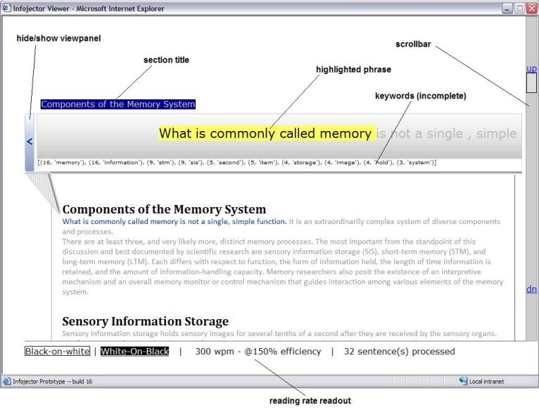

Figure naming format is as follows.. chapter.figure_number_in chapter. The next figure in chapter 1 would be 1.2

Figure 1.1 – Elements of the Infojector utility [1]

In the dynamic text display, each sentence was chunked into phrases according to the natural language toolkit’s (Bird, Klein and Loper, 2001) chunking algorithm to closely emulate the natural way readers chunk sentences when read or spoken.

1.1.1 Sub Sub Heading

Intonation is described as the psychological perception of the variation of pitch during an utterance. It is also considered to be the tune of an utterance or the fundamental frequency (F0) produced by voiced speech. According to Rosenberger (1998), a high degree of precision is evidenced during intonation.

3.1.6.2 Sub Sub Sub Heading

Rhythm in the design was based on the general duration patterns encountered in speech and reading. When dynamically presenting text, rhythm is projected in the varying specifications of word display times which aim to draw parallels to that of speech and reading. In retrospect, the prosodic element of rhythm
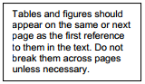
Tables should be formatted as shown here
Table 1.1
Reading texts used in the evaluation
Passage | Title | Source | Words | Flesch Score
1 | Airbus Crisis Over | BEC Business English Certificate Preliminary Exam | 360 | 44.45
2 | Which is the hardest language? | Intermediate comprehension exercise for ESL Exam | 488 | 40.30
3 | The Digital Divide | PET Preliminary English Test | 224 | 50.50
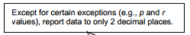

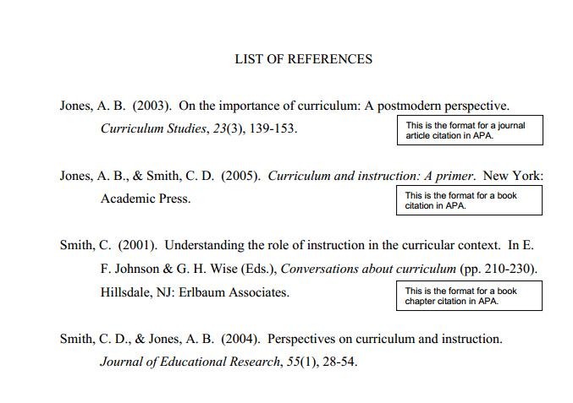

This is the format for citing web sites (n.d is used if no date for the site is available)

